##### *ORL.44 – Enable/Disable a Process*

##### *General Information*

3

**EPIC :** Process Library **Story Point :**

**Linked UC document :** [Identification name of the UC document linked with the US]

**Author :** Benjamin AZZARA

**Product Owner :** Damien GIRAUD **Business Value : High**

##### *Details* [Simple and understandable description of the functionality, it must be « User oriented »]

**As a** End User

**I want**  To be able to enable/disable a Process

**So that**  I can manage the status of the Process

##### Business Context

* *Process* :
* *Context : Process Library*
* *Identified Impacts : No*
* *Prerequisite :*
* *Entities :*

##### *User Interface*

Mock-up 1

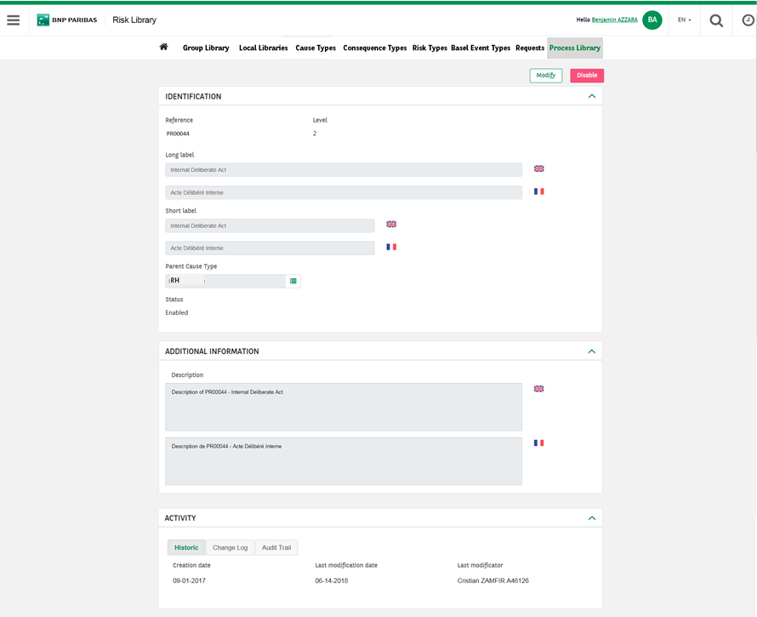



Mock-up 2



Mock-up 3

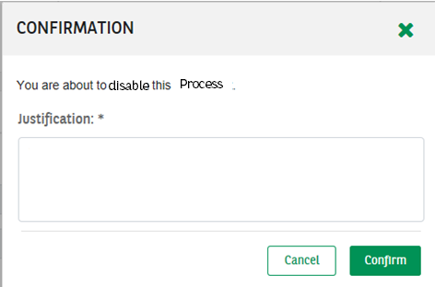

Mock-up 4

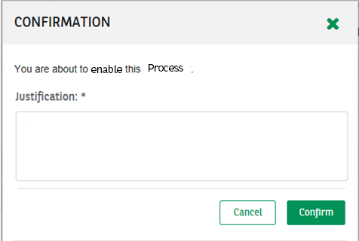

##### Acceptance Criteria

|  |  |  |  |
| --- | --- | --- | --- |
| **#** | **Business rules reference** | **Description** | **Mock-up** |
|  | **RG.RLI.OBJ** | A Process has the status “Enabled” by default | 2 |
|  | **RG.RLI.GUI** | In the Consultation form of an Enabled Process, the button “Disable” is displayed | 2 |
|  | **RG.RLI.OBJ** | Clicking on “Disable” displays a justification pop-up (MANDATORY) | 3 |
|  | **RG.RLI.GUI** | The black stripe should appears in the consultation form of the Process and in the Treeview of Process |  |
|  | **RG.RLI.OBJ** | In the justification pop-up, clicking on “Confirm” displays the concerned Process. A green toaster is to be displayed on the top right corner of the screen saying “The Process PRXXXXX has been disabled” Its status is now “Disabled” |  |
|  | **RG.RLI.OBJ** | In the justification pop-up, clicking on “Cancel” displays the concerned Process. Its status stays unchanged |  |
|  | **RG.RLI.GUI** | In the Consultation form of a Disabled Process, the button “Enable” is displayed | 1 |
|  | **RG.RLI.OBJ** | Clicking on “Enable” displays a justification pop-up (MANDATORY) | 4 |
|  | **RG.RLI.OBJ** | In the justification pop-up, clicking on “Confirm” displays the concerned Process. A green toaster is to be displayed on the top right corner of the screen saying “The Process PRXXXXX has been enabled” Its status is now “Enabled” |  |
|  | **RG.RLI.OBJ** | In the justification pop-up, clicking on “Cancel” displays the concerned Process. Its status stays unchanged |  |
|  | **RG.RLI.GUI** | When a Process is “Disabled”, except for the “Enable” button, there is no button displayed |  |
|  | **RG.RLI.OBJ** | The enabling of a Process generates a Business Event “Activation” in its Change Log |  |
|  | **RG.RLI.OBJ** | The disabling of a Process generates a Business Event “Deactivation” in its Change Log |  |